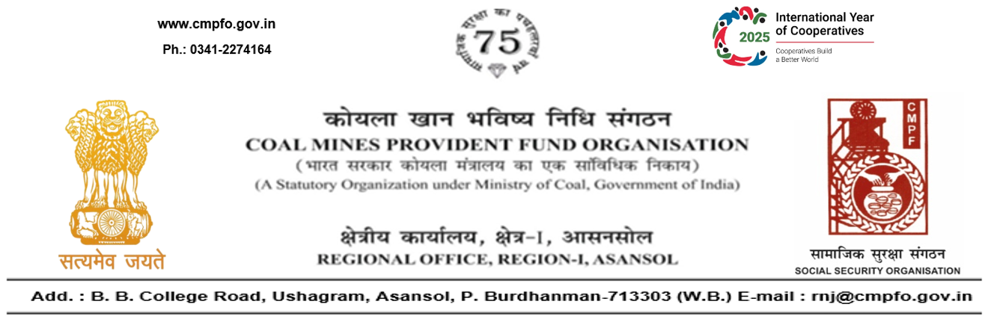
CPF/118/Misc/L.C.Out./RNJ-38/R-I/ASN/ Date: 01/01/2026

To,
The Assistant Commissioner
Office of the Assistant Commissioner
Coal Mines Provident Fund Organisation
Sonali Building, Court More, VIP Chowk,
Deoghar-814112
(Jharkhand)

Sub:- Inter Regional Transfer of Ledger Card, DA, PS -3 & 4.

Ref:-CPF/Misc/ L.C. Req./DGR/1757 dated 12/12/2025
Sir,
In view of the revised Procedures prescribed in Procedure Office Order No-35 Dated-12.02.1975 of CMPF Commissioner,Dhanbad, I am to state that the Ledger Cards of the following members is hereby forwarded to your Regional Office. Further, it is informed that the Form A & P.S.-3 & P.S.-4 forms are not available in this region.
It has been ensured that the posting in the Ledger Cards have been made/updated for the periods the member was working in this Region.

SL. No | Name of the Member | CMPF A/C No | Name of the colliery where the member had earlier worked in | Name of the colliery where the member is currently working in
1 | Shri Arun Kumar | RNJ/19/1283 | TilaboniColliery,Bankola Area (15.03.1988 to 16.05.2022,Nakrakonda-Kumardihi ‘B’ Colliery,Bankola Area (17.05.2022 to 04.08.2024) | Rajmahal OCP (DGR-5)
2 | Shri Satya Narayan Mahato | RNJ/22/1439 | Khandra colliery (RNJ/22) And Moira Colliery (RNJ/21)  L.C. Not Available (Response Attached)) | Rajmahal OCP (DGR-5)

Please acknowledge the receipt of the above at the earliest.

Yours faithfully,

(Ajay Kumar Singh)
Encl- Original L.C. & Response (One each) Regional Commissioner - I

